MINISTRY OF EDUCATION AND TRAINING
THUONGMAI UNIVERSITY
-------------------------

Phan Nam Thái

FACTORS AFFECTING LABOR PRODUCTIVITY OF FOOD MANUFACTURING AND PROCESSING ENTERPRISES IN THE RED RIVER DELTA REGION

Major: Business Administration
Code: 9340101

Summary of the doctoral dissertation in economics

Hanoi, Year 2025

The dissertation was completed at Thuongmai University

Science instructor 1: PGS, TS. Trần Kiều Trang
Science instructor 2: PGS, TS. Nguyễn Duy Đạt

Reviewer 1:
……………………………………….……………………………
……………………………………….……………………………
Reviewer 2:
……………………………………….……………………………
……………………………………….……………………………
Reviewer 3:
……………………………………….……………………………
……………………………………….……………………………

The dissertation will be defended before the University-level Dissertation Evaluation Council meeting at the Thuongmai University.
At …… o'clock on …… day of …… month of …… year

The thesis can be found at: National Library
Library of the Thuongmai University

INTRODUCTION

1. Reasons for choosing the topic
In the context of increasingly intense competition, productivity has become a core factor determining the competitiveness of enterprises. Labor productivity is a common form of productivity. It reflects the efficiency of generating output per unit of labor, while being influenced by various non-labor factors such as capital, technology, and managerial capability. Globally, numerous studies have examined the factors affecting labor productivity at both theoretical and empirical levels. However, in Vietnam, existing research has primarily focused on the industry level or the overall economy. Studies investigating the determinants of labor productivity at the enterprise level remain limited. Notably, no in-depth study has analyzed the factors influencing labor productivity among enterprises in the food manufacturing and processing sector across different economic regions of Vietnam.
The Red River Delta region, including the capital city of Hanoi, is one of Vietnam’s most important economic areas. Nevertheless, the labor productivity of enterprises in this region—including food manufacturing and processing firms—remains relatively low. Although the Red River Delta possesses favorable conditions for the development of the food processing industry, enterprises in this sector have not yet fully leveraged their potential to firmly assert their important role in the national economy, such as contributing foreign exchange earnings, promoting agricultural development, and ensuring national food security.
Therefore, researching the factors influencing labor productivity among food manufacturing and processing enterprises in the Red River Delta region not only enriches and refines the theoretical foundation on labor productivity but also provides essential evidence for proposing recommendations aimed at improving labor productivity. This, in turn, enhances operational efficiency, strengthens enterprise competitiveness, and contributes positively to the economic development of both the region and the nation.

2. Research purposes and tasks
This dissertation is primarily conducted to analyze the current state of labor productivity and the factors influencing labor productivity of food manufacturing and processing enterprises in the Red River Delta. At the same time, it tests the proposed research model and assesses the magnitude of the effects of these factors on labor productivity, thereby proposing several recommendations to enhance labor productivity in these enterprises.

3. Research subject and scope
Research subject: the factors influencing labor productivity of food manufacturing and processing enterprises in the Red River Delta region.
Research scope:
- Scope of content: The dissertation focuses on analyzing and evaluating five key factors affecting labor productivity of food manufacturing and processing enterprises in the Red River Delta, including capital, labor quality, research and development (R&D), managerial capability of middle managers, and enterprise size.
- Scope of space: The study covers food manufacturing and processing enterprises located in the Red River Delta region.
- Scope of time: Secondary data used for analysis were mainly collected during the period 2018–2024. Primary data were collected from November 2023 to June 2024 through interviews and surveys. Recommendations are proposed toward 2030 to align with the Government’s planning decisions for the Red River Delta region for the period 2021–2030.

4. Research methods
The dissertation employs a combination of qualitative and quantitative research methods to ensure a comprehensive, objective, and in-depth analysis of the factors influencing labor productivity of food manufacturing and processing enterprises in the Red River Delta region.

5. New contributions of the dissertation
In terms of theory:
-The dissertation systematizes and develops a more comprehensive theoretical framework on labor productivity and the factors influencing labor productivity at the enterprise level. In addition, it clarifies and specifies the concept of labor productivity of manufacturing enterprises.
- Based on scientific arguments and by inheriting and advancing prior domestic and international studies, the dissertation establishes measurement scales and constructs a research model identifying key factors affecting labor productivity of manufacturing enterprises, such as capital, labor quality, research and development (R&D), and enterprise size. Notably, the dissertation contributes to enriching and refining the theoretical foundation on enterprise-level labor productivity by incorporating the independent variable “managerial capability of middle managers” into the research model, thereby clarifying its impact on labor productivity of manufacturing enterprises.
- The dissertation empirically validates the research model using survey data from food manufacturing and processing enterprises in the Red River Delta region. The results confirm that the measurement scales are reliable and that all factors—capital, labor quality, R&D, enterprise size, and the managerial capability of middle managers—positively and significantly influence labor productivity of these enterprises.
In terms of practice:
- Based on the primary and secondary data collected, the dissertation analyzes and evaluates the current status of labor productivity and its influencing factors in food manufacturing and processing enterprises in the Red River Delta, including capital, labor quality, R&D, enterprise size, and the managerial capability of middle managers. Furthermore, it identifies the degree of impact each factor has on labor productivity of these enterprises.
- The dissertation proposes feasible recommendations targeting these influencing factors with the aim of improving labor productivity of food manufacturing and processing enterprises in the Red River Delta region by 2030.

6. Structure of the dissertation

CHAPTER 1: OVERVIEW OF RELATED STUDIES

1.1. Studies on productivity and labor productivity of manufacturing enterprises

1.2. Studies on factors affecting labor productivity of manufacturing enterprises

1.3. Studies on factors affecting labor productivity of food manufacturing and processing enterprises

1.4. Research gaps
The review of existing studies indicates that several research gaps remain and need further clarification in order to contribute to refining the theoretical framework and providing additional empirical evidence for policymaking and enterprise management. Specifically:
- Internationally, studies on labor productivity and the factors influencing labor productivity of manufacturing enterprises (including food manufacturing and processing enterprises) often do not clearly define or specify the concept of labor productivity at the enterprise level. In addition, most empirical studies focus on only one or a few factors affecting labor productivity of manufacturing enterprises.
- In Vietnam, research has mainly approached labor productivity and its determinants at the industry level or the overall economy, with limited studies examining labor productivity and its influencing factors at the enterprise level. Notably, very few studies investigate the determinants of labor productivity of food processing enterprises.
- There is no in-depth study on the factors influencing labor productivity of food processing enterprises in the Red River Delta region, nor any research addressing the impact of the managerial capability of middle managers on the labor productivity of these enterprises.

CHAPTER 2: THEORETICAL FRAMEWORK ON LABOR PRODUCTIVITY AND FACTORS INFLUENCING LABOR PRODUCTIVITY OF MANUFACTURING ENTERPRISES

2.1. Some theoretical foundations on manufacturing enterprises

2.1.1. Concepts and types of manufacturing enterprises

2.1.1.1. Concept of manufacturing enterprises
A manufacturing enterprise is a legally established organization whose purpose is to transform input factors such as capital, labor, technology, and management into outputs in the form of goods to meet societal needs.

2.1.1.2. Types of manufacturing enterprises
- Classification by legal liability and organizational model: This includes private enterprises, joint-stock companies, single-member limited liability companies, multi-member limited liability companies, and partnerships.
- Classification by size based on the number of employees and revenue or capital: micro manufacturing enterprises, small manufacturing enterprises, medium manufacturing enterprises, and large manufacturing enterprises.
- Classification by sector of operation: This includes enterprises such as food manufacturing and processing enterprises, beverage-producing enterprises, metal manufacturing enterprises, automobile and other motor vehicle manufacturing enterprises, and so on.

2.1.2. Production function
A production function represents the relationship between inputs and outputs in the transformation process and indicates the maximum quantity of goods that can be produced from various combinations of given input factors.
The general form of a production function is:
Y = F$\left(x_{1}, x_{2},{……,x}_{n}\right)$
One of the most commonly used production functions in economics is the Cobb–Douglas production function, expressed as follows:
$$Y={A.K}^{α}L^{β}$$
Where: Y is the total output; K is capital; L is labor; A represents other input factors affecting total output; α and β are the output elasticities of capital and labor, respectively.

2.2. Concepts of productivity and labor productivity of manufacturing enterprises

2.2.1. Concept of productivity of manufacturing enterprises
Productivity of manufacturing enterprises can be understood as the ratio between output and input in the enterprise’s production activities. It reflects the quantity of goods produced per unit of input.

2.2.2. Concept of labor productivity of manufacturing enterprises
Labor productivity of manufacturing enterprises is a specific form of productivity, representing the quantity of goods produced per unit of labor input.

2.3. The Role of enhancing labor productivity of manufacturing enterprises

2.3.1. Role for manufacturing enterprises
Improving labor productivity enables manufacturing enterprises to enhance their competitiveness, achieve sustainable profit growth, and retain as well as attract a high-quality workforce.

2.3.2. Role for the economy
Improving labor productivity of manufacturing enterprises contributes to promoting sustainable economic growth.

2.4. Methods for measuring labor productivity of manufacturing enterprises

2.4.1. Measuring labor productivity in physical or quantitative terms
Labor productivity (NSLĐ) measured in physical or quantitative terms is determined as follows:
$$NSLĐ=\frac{Y}{L}$$
Where: Y is the total output measured in physical or quantitative units (pieces, units, kilograms, tons, meters, cubic meters, etc.).
L is the total number of workers or the total labor time required to produce the total output Y.

2.4.1. Measuring labor productivity in value terms
Labor productivity measured in value terms is determined as follows:
$$NSLĐ=\frac{Y}{L}$$
Where: Y is the total output measured in monetary terms (Vietnamese đồng, US dollars, etc.). Y may represent value added, revenue, and so on.
L is the total number of workers or the total labor time required to produce the total output Y.

2.4.3. Labor productivity measured per hour worked

2.4.4. Average labor productivity

2.4.5. Marginal labor productivity

2.5. Factors influencing labor productivity of manufacturing enterprises
Labor productivity of manufacturing enterprises is influenced not only by labor-related factors but also by all other factors involved in and affecting the production process. To produce goods, a manufacturing enterprise must transform various inputs such as capital, labor, and technology. These input factors are themselves affected by external factors—such as economic conditions, political institutions, policies and regulations, and technological developments—which in turn influence the labor productivity of the enterprise. Overall, the factors affecting labor productivity of manufacturing enterprises can be classified into external and internal factors.

2.5.1. External factors affecting manufacturing enterprises

2.5.1.1. Economic environment factors

2.5.1.2. Political, policy, and legal environment factors

2.5.1.3. Technological environment factors

2.5.1.4. Cultural and social environment factors

2.5.1.5. Other external factors

2.5.2. Internal factors affecting manufacturing enterprises

2.5.2.1. Capital of manufacturing enterprises

2.5.2.2. Labor quality of manufacturing enterprises

2.5.2.3. Research and development (R&D)

2.5.2.4. Managerial capability of managers in manufacturing enterprises

2.5.2.5. Enterprise size

2.6. Research model and research hypotheses on factors influencing labor productivity of manufacturing enterprises

2.6.1. Research Model
There are numerous factors that influence the labor productivity of manufacturing enterprises. However, due to resource limitations, the dissertation focuses only on a number of typical factors that have a direct impact on labor productivity and can be controlled by the enterprise. Specifically, in addition to traditional factors such as capital and enterprise size, the dissertation proposes three other representative factors that directly affect labor productivity of manufacturing enterprises: labor quality, research and development (R&D), and the managerial capability of middle managers.
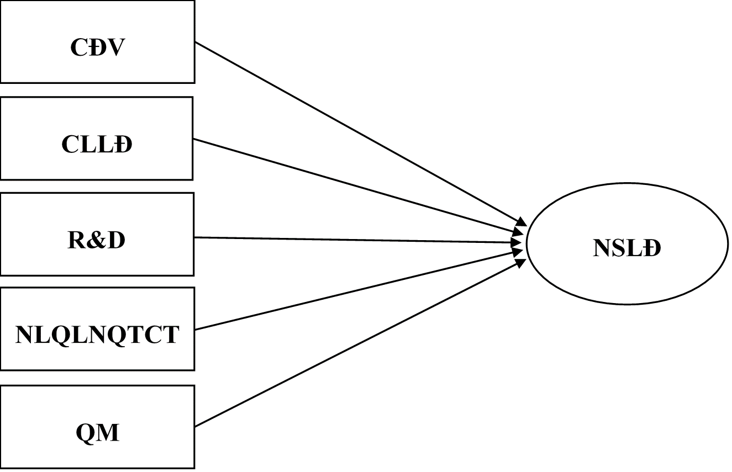
Figure 2.2: Research Model
The research model consists of one dependent variable—labor productivity (NSLĐ) and five independent variables: capital (CĐV), labor quality (CLLĐ), research and development (R&D), the managerial capability of middle managers (NLQLNQTCT), and enterprise size (QM). To estimate the degree of influence of these factors, the dissertation employs a production function similar to the Cobb–Douglas production function, resulting in the following natural logarithm linear regression equation:

$${LnNSLĐ}_{it}=β_{0}+β_{1}Ln{CĐV}_{it}+β_{2}Ln{CLLĐ}_{it}+β_{3}Ln{R\&D}_{it}+β_{4}Ln{NLQLNQTCT}_{it}+β_{5}Ln{QM}_{it}+ε_{it}$$

2.6.2. Research Hypotheses
Based on previous studies, the dissertation proposes five hypotheses as follows:
Hypothesis 1 (H1): The capital of manufacturing enterprises has a positive effect on their labor productivity.
Hypothesis 2 (H2): The labor quality of manufacturing enterprises has a positive effect on their labor productivity.
Hypothesis 3 (H3): Research and development (R&D) in manufacturing enterprises has a positive effect on their labor productivity.
Hypothesis 4 (H4): The managerial capability of middle managers in manufacturing enterprises has a positive effect on their labor productivity.
Hypothesis 5 (H5): The size of manufacturing enterprises has a positive effect on their labor productivity.

CHAPTER 3: RESEARCH METHODOLOGY

3.1. Research process
The research process consists of seven main steps: (1) Reviewing the literature; (2) Identifying research gaps; (3) Developing the theoretical framework, research model, measurement scales, and designing a preliminary questionnaire; (4) Integrating expert interview results to finalize the research model, hypotheses, measurement scales, and the official questionnaire; (5) Sampling and conducting the survey to collect data; (6) Processing and analyzing the data, and validating the measurement scales and research hypotheses; (7) Discussing the research findings and proposing managerial implications.

3.2. Developing measurement scales and designing the research survey questionnaire

3.2.1. Developing measurement scales
The measurement scales for the variables are developed by selectively inheriting and adapting scales from previous studies conducted by domestic and international scholars, ensuring their suitability for the research context. In this dissertation, the managerial capability of middle-level managers is a qualitative variable quantified using a 7-point Likert scale. Accordingly, the original scales of the remaining quantitative variables are transformed to the same 7-point Likert scale using linear interpolation. This transformation aims to mitigate the influence of outliers and to ensure scale consistency in the regression analysis (Venkatraman & Ramanujam, 1986; Wall et al., 2004).

3.2.1.1. Labor productivity measurement scale

3.2.1.2. Capital measurement scale

3.2.1.3. Labor quality measurement scale

3.2.1.4. Research and development measurement scale

3.2.1.5. Middle managerial competence measurement scale

3.2.1.6. Enterprise size measurement scale

3.2.2. Survey questionnaire design

3.3. Data collection methods, sampling, and research sample overview

3.3.1. Secondary data collection

3.3.2. Primary data collection

3.3.3. Research sample selection

3.3.4. Research sample overview

3.4. Data processing methods
The data processing in this thesis is primarily based on SPSS 26 software. The steps for analyzing and processing data include:
- (1) Comparative and descriptive statistics: Assessing the maximum, minimum, mean, and standard deviation of variables;
- (2) Measurement scale testing for middle managerial competence: Conducted through reliability analysis (examining Cronbach’s Alpha) and exploratory factor analysis (EFA);
- (3) Research hypothesis testing: This involves checking the assumptions of regression using indicators such as Durbin-Watson, VIF, Pearson correlation analysis combined with scatter plots, and testing the fit of the regression model through indicators such as R², F-test (ANOVA), as well as examining standardized beta coefficients (β) and the statistical significance of each independent variable using p-values.

CHAPTER 4: RESEARCH RESULTS ON FACTORS AFFECTING LABOR PRODUCTIVITY OF FOOD MANUFACTURING AND PROCESSING ENTERPRISES IN THE RED RIVER DELTA REGION

4.1. Overview of natural, economic, and social conditions in the red river delta region

4.1.1. Some natural and social characteristics

4.1.2. Some economic characteristics

4.2. Overview of food manufacturing and processing enterprises

4.2.1. Some characteristics of the food manufacturing and processing industry

4.2.2. Business performance and contributions of food manufacturing and processing enterprises to the economy

4.2.2.1. Some business performance results

4.2.2.2. Some contributions to the economy

4.3. The current state of labor productivity and its influencing factors in food manufacturing and processing enterprises in the Red River Delta

4.3.1. The current state of labor productivity of enterprises in the research sample
Based on survey data from 260 food manufacturing and processing enterprises in the Red River Delta, the results show that the highest level of labor productivity reaches 2,763 million VND per worker, while the lowest is 16 million VND per worker. The majority of enterprises exhibit labor productivity below the average level (with the average labor productivity of food manufacturing and processing enterprises in the Red River Delta amounting to 199 million VND per worker). This indicates that labor productivity in these enterprises remains limited, has not yet demonstrated a comparative advantage relative to the overall level of the manufacturing and processing industry, and has not made a significant contribution to labor productivity growth in the Red River Delta as a whole.

4.3.2. The current state of factors influencing labor productivity of enterprises in the research sample

4.3.2.1. The current state of capital
Overall, there exists a considerable disparity in capital investment in machinery and equipment per worker among food manufacturing and processing enterprises in the Red River Delta. Of the 260 surveyed enterprises, only 80 report investment levels above the average. Moreover, the average level of capital investment of these enterprises remains relatively low compared to the overall average of the manufacturing and processing industry. This indicates that capital investment in machinery and equipment per worker among food manufacturing and processing enterprises in the Red River Delta is still limited, and it also reflects the fact that many enterprises continue to rely on outdated machinery, equipment, and technologies.

4.3.2.2. The current state of labor quality
The average proportion of trained labor in food manufacturing and processing enterprises in the Red River Delta region is relatively high, reaching 49.8%. Among the 260 surveyed enterprises, 37 have 100% of their workforce trained. However, there are also 8 enterprises with a proportion of trained labor below 10%.

4.3.2.3. The current state of research and development (R&D)
Among the surveyed food manufacturing and processing enterprises in the Red River Delta, 56% have R&D expenditure as a percentage of revenue below 1.5%, while only 14% have R&D expenditure above 3% of revenue. This situation reflects the fact that many food manufacturing and processing enterprises in the Red River Delta still underestimate the importance of R&D activities.

4.3.2.4. The current state of managerial capability of middle managers
The survey results, based on the evaluation of three groups of factors—management knowledge, management skills, and managerial attitudes/qualities—show that the competence of middle managers in food manufacturing and processing enterprises in the Red River Delta is rated as “Quite Good,” with an average score of 4.89. The highest rating recorded is “Very Good” at 6.61, while the lowest is “Somewhat Weak” at 3.39.
Among the three evaluated factor groups, management skills are rated the highest, while management knowledge is rated the lowest. This reflects that middle managers have more opportunities to enhance their management skills through regular practice within enterprises. However, opportunities for learning and training to update and improve their management knowledge remain limited.

4.3.2.5. The current state of enterprise size
The survey results indicate that up to 87% of food manufacturing and processing enterprises in the Red River Delta region are small and medium-sized. The smallest recorded workforce is 8 employees, while the largest enterprise employs up to 2,265 workers. The average workforce of these enterprises is 123 employees, reflecting a relatively high level of labor utilization. These figures indicate that food manufacturing and processing enterprises in the Red River Delta are labor-intensive.

4.4. Results of the research model testing

4.4.1. Research measurement scale testing

4.4.1.1. Reliability analysis of the measurement scale
The data processing results show that the Cronbach’s Alpha coefficients for the factor groups are greater than 0.7, and the smallest item-total correlations are greater than 0.3. This demonstrates that the measurement scale for middle managerial competence is reliable and suitable for exploratory factor analysis - EFA.

4.4.1.2. Exploratory factor analysis - EFA
The synthesis of the measurement scale testing results indicates that the scale for middle managerial competence is fully appropriate. The scale consists of 38 observed variables, 3 first-order variables, and 1 second-order variable, formed as expected. Specifically:
- The EFA applied to the first-order variables shows a KMO index of 0.960, and the Bartlett’s test is statistically significant with Sig.<0.01, indicating that the research data is suitable for exploratory factor analysis (EFA). From the 38 observed variables, three factors were extracted as expected, with a total cumulative variance of 57.25% and an Eigenvalue cutoff of 2.401. Furthermore, the factor loadings, reflecting the correlation between observed variables and factors, are all greater than 0.5, and the difference in factor loadings between an observed variable and other factors is greater than 0.3, demonstrating both convergent and discriminant validity of the scale.
- The EFA applied to the second-order variable shows a KMO = 0.601 > 0.5; Bartlett’s test is statistically significant with Sig.<0.01; the total cumulative variance is 65.58% > 50%, and the Eigenvalue cutoff is 1.967 > 1. Thus, the three first-order variables were successfully extracted into one second-order factor as expected.

4.4.2. Research hypothesis testing

4.4.2.1. Testing the assumptions of the multiple linear regression model
- Linear relationship between independent and dependent variables: The results of the Pearson correlation analysis and scatter plots between each independent variable and the dependent variable indicate that the independent variables in natural logarithm form (ln) all have a linear relationship with the dependent variable in natural logarithm form (ln).
Table 4.15: Pearson correlation analysis results between
each independent variable and the dependent variable
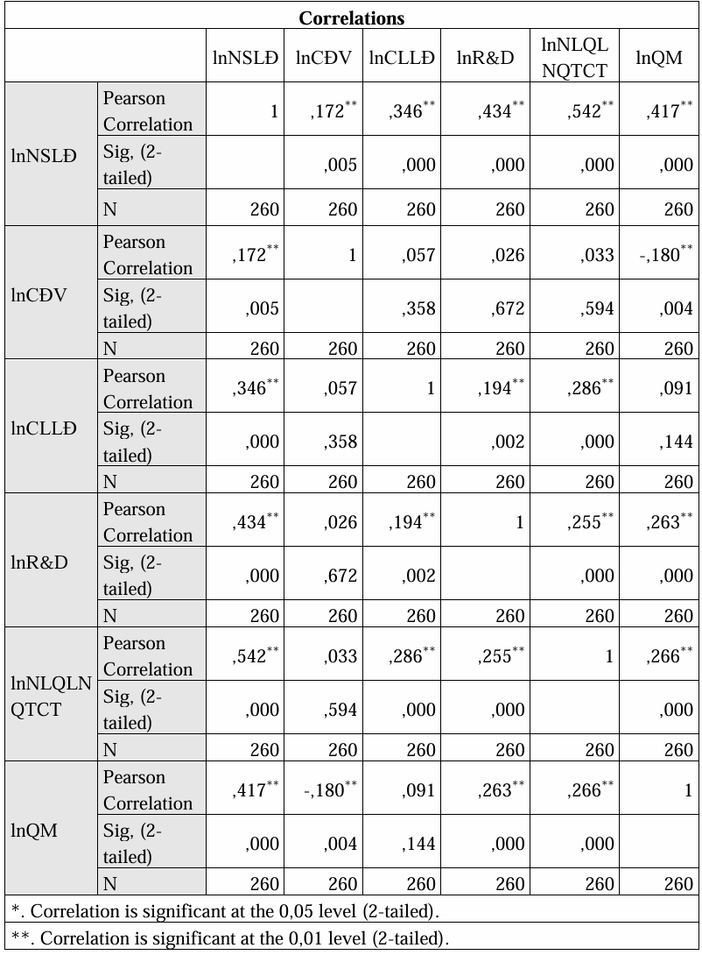
(Source: Survey data processing results via SPSS by the researcher)
- Testing the independence of errors in the research model: The results show that the Durbin-Watson statistic is 1.705 > 1.5, indicating that the errors in the research model are independent of each other.
- Testing multicollinearity among independent variables: The results indicate that the variance inflation factor (VIF) values are all less than 5 and greater than 1, demonstrating that there is no multicollinearity among the independent variables in natural logarithm form (ln) in the research model.
Table 4.16: Assessment of multicollinearity among
independent variables
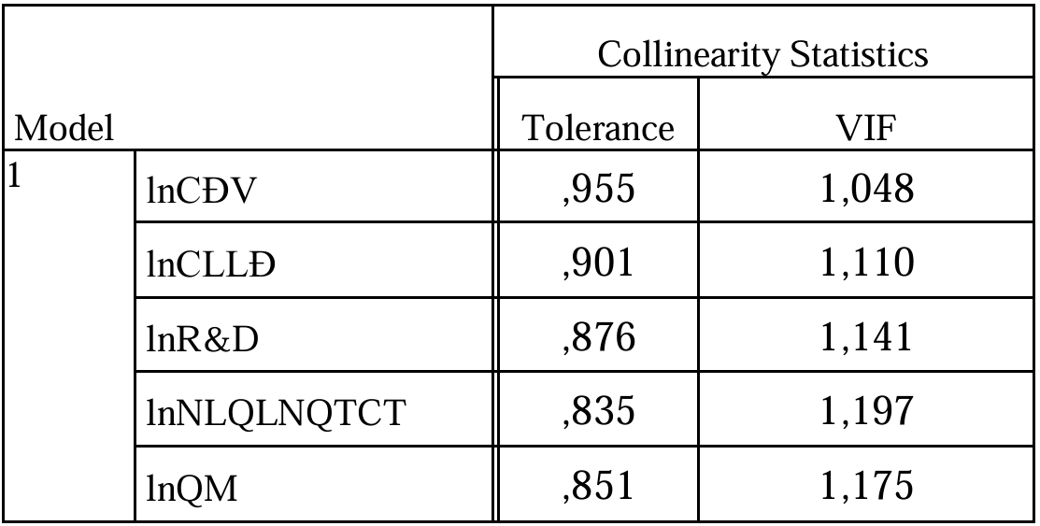
(Source: Survey data processing results via SPSS by the researcher)
- Testing whether the standardized residuals vary with the predicted values of independent variables: By examining the scatter plot of standardized residuals against the predicted values of the independent variables in natural logarithm form (standardized), the points are randomly distributed around the line y = 0, without forming a clear funnel, curved, or clustered pattern. This indicates that the model satisfies the homoscedasticity assumption.
- Testing whether the standardized residuals are normally distributed: The normality of the standardized residuals is assessed using scatter plots. The results show that the histogram of residuals has a symmetric bell-shaped form, and the Normal P-P Plot shows that the residuals lie close to the diagonal line, indicating that the standardized residuals are normally distributed.

4.4.2.2. Testing the fit of the regression model
- The test results indicate that the variation of the dependent variable, labor productivity in natural logarithm form (LnNSLĐ), can be fairly well explained by the independent variables in natural logarithm form, including capital (LnCĐV), labor quality (CLLĐ), research and development (LnR&D), middle management managerial capacity (LnNLQLNQTCT), and scale (LnQM), with an R² value of 0.661. In addition, the F-statistic = 99.013 with a significance level of Sig. < 0.01 indicates that the survey results from the sample can be generalized to the population.
- The test results show that the standardized Beta coefficients of the independent variables in natural logarithm form are statistically significant, with Sig. < 0.01. This confirms that all the research hypotheses proposed are accepted. Furthermore, the positive standardized Beta coefficients indicate that the independent variables in the model have a positive effect on the dependent variable.
Table 4.18: Results of hypothesis testing
No. | Hypothesis | Beta | p-value | Results
H1 | The capital of manufacturing enterprises has a positive effect on their labor productivity | 0,195 | <0,01 | Accepted
H2 | The labor quality of manufacturing enterprises has a positive effect on their labor productivity | 0,176 | <0,01 | Accepted
H3 | Research and development (R&D) in manufacturing enterprises has a positive effect on their labor productivity | 0,357 | <0,01 | Accepted
H4 | The managerial capacity of middle-level managers in manufacturing enterprises has a positive effect on their labor productivity | 0,429 | <0,01 | Accepted
H5 | The size of manufacturing enterprises has a positive effect on their labor productivity | 0,272 | <0,01 | Accepted
(Source: Survey data processed by the researcher)

CHAPTER 5: DISCUSSION OF RESEARCH FINDINGS AND RECOMMENDATIONS TO IMPROVE LABOR PRODUCTIVITY OF FOOD MANUFACTURING AND PROCESSING ENTERPRISES IN THE RED RIVER DELTA REGION

5.1. Discussion of research findings

5.1.1. The impact of factors affecting labor productivity of enterprises
The level of impact of factors affecting the labor productivity of food manufacturing and processing enterprises in the Red River Delta region was determined through a linear logarithmic regression equation:
LnNSLĐ = 0,195*LnCĐV + 0,176*LnCLLĐ + 0,357*LnR&D + 0,429*LnNLQLNQTCT + 0,272*LnQM
The research results indicate that the influencing factors, including capital, labor quality, research and development, the managerial capacity of middle-level managers, and enterprise scale, all have a positive and significant impact on the labor productivity of food manufacturing and processing enterprises in the Red River Delta region. These findings are also consistent with the conclusions of previous notable international studies.
Among the five influencing factors, the strongest factor affecting labor productivity of food manufacturing and processing enterprises in the Red River Delta region is the managerial capacity of middle-level managers. The estimation results show that, ceteris paribus, a 1% increase in the managerial capacity of middle-level managers corresponds to a 0.429% increase in enterprise labor productivity, and vice versa. This confirms the key role of middle-level managers in organizing, directing, and optimizing production activities, thereby contributing to the growth of labor productivity.

5.1.2. General assessment of labor productivity of food manufacturing and processing enterprises in the red river delta region

5.1.2.1. Advantages
The Red River Delta region also has food manufacturing and processing enterprises with high labor productivity, outperforming the industry average. These enterprises are all large-scale, with 100% of their workforce having received formal training. In addition, the managerial capacity of middle-level managers in these enterprises is rated as “Excellent,” and the enterprises place strong emphasis on investment in research and development activities.

5.1.2.2. Limitations and causes
- Limitations: Most food manufacturing and processing enterprises in the Red River Delta region have low labor productivity, even lower than the regional and national averages.
- Objective Causes:
+ The business environment, including institutions and policies, still contains many barriers that need to be continuously reformed and improved toward
+ The government has only set labor productivity growth targets at the overall Red River Delta regional level but has not established specific targets for individual enterprise groups by industry, including food manufacturing and processing enterprises. This lack of targeted guidance results in priority policies and support programs either not being issued or being delayed, failing to meet the actual and timely needs of enterprises, especially those that play a significant role in the regional economic structure.
+ There is still a shortage of government policies and support programs specifically for food manufacturing and processing enterprises in the Red River Delta region.
+ The quality of education and vocational training in the Red River Delta has improved recently but still shows a significant gap compared to international standards.
- Subjective causes:
+ Physical facilities such as workshops and warehouses are poor, fragmented, and lack synchronization, coupled with a shortage of modern machinery and outdated technology. Although some food manufacturing and processing enterprises in the Red River Delta have invested in advanced production lines, most small and medium-sized enterprises still face obstacles in upgrading technology and acquiring modern machinery, partly due to high investment costs and partly due to limited access to financing.
+ Labor quality in many food manufacturing and processing enterprises in the Red River Delta remains limited, as they primarily rely on unskilled and seasonal workers, resulting in low labor productivity. Additionally, training policies, compensation schemes, and working environments are not adequate, leading to a lack of motivation among employees, reducing the effectiveness of human resource utilization, and negatively affecting overall labor productivity.
+ Research and development activities in many enterprises are still neglected due to small enterprise size, low access to capital, and high investment costs. Moreover, the workforce mainly consists of unskilled laborers or low-level technicians, lacking experts and highly qualified personnel, which makes it difficult for enterprises to innovate technology, improve production processes, and enhance the added value of products.
+ The managerial capacity of middle-level managers in these enterprises is still limited. In particular, middle-level managers often lack management knowledge, creativity, and initiative, and their job satisfaction and engagement remain low. This is partly due to the managers’ insufficient proactiveness in self-development and partly due to limitations in recruitment, compensation, and training policies in food manufacturing and processing enterprises in the Red River Delta.
+ Most food manufacturing and processing enterprises in the Red River Delta are small and medium-sized, making it difficult to exploit economies of scale, leading to high production costs and stagnant labor productivity. Limited scale also results in stricter lending conditions from financial institutions, hindering investment in machinery and modern technology and restricting production expansion and productivity improvement.

5.2. Development prospects and perspectives on improving labor productivity of food manufacturing and processing enterprises in the red river delta region

5.2.1. Development prospects of food manufacturing and processing enterprises in the Red river delta region by 2030

5.2.1.1. Opportunities
The development prospects of food manufacturing and processing enterprises in the Red River Delta region by 2030 are considered highly potential due to favorable factors such as government policies and support, diverse input materials, growth in domestic and export demand, and consumer trends favoring clean, nutritious, safe, and convenient food products.

5.2.1.2. Challenges
Alongside opportunities, enterprises also face significant challenges, such as strict regulations on food hygiene and safety, domestic and international competition, and instability in the supply of input materials.

5.2.2. Perspectives on improving labor productivity of food manufacturing and processing enterprises in the Red river delta region by 2030

5.3. Recommendations to improve labor productivity of food manufacturing and processing enterprises in the Red river delta region by 2030

5.3.1. Recommendations for enterprises
- First, food manufacturing and processing enterprises in the Red River Delta region should focus on improving the level of capital investment per employee by increasing investment and upgrading offices, workshops, storage facilities, equipment, and modern machinery.
- Second, enterprises need to focus on enhancing labor quality through (1) recruitment policies, (2) guidance and training for employees, (3) appropriate salary, reward, and incentive policies, and (4) improving working conditions and the work environment.
- Third, enterprises should prioritize and increase investment in research and development activities proportionate to their revenue scale.
- Fourth, enterprises need to enhance the managerial capacity of middle-level managers through specialized training programs, attractive salary and incentive policies, and improved working environments.
- Fifth, enterprises should focus on expanding and increasing the scale of their operations.

5.3.2. Recommendations for the Government
- First, the government needs to continue improving and reforming institutional frameworks.
- Second, the government should establish additional labor productivity targets for food manufacturing and processing enterprises in the Red River Delta region within the decisions on regional planning for the Red River Delta for each period.
- Third, the government should focus on improving the quality of education and vocational training.
- Fourth, the government should issue practical, specific mechanisms, policies, and support programs dedicated to food manufacturing and processing enterprises in the Red River Delta, such as: (1) Financial support policies and programs; (2) Policies for developing large input material areas; (3) Investment and construction policies for synchronized infrastructure;(4) Programs encouraging and supporting research and development activities; (5) Communication and workshop programs on labor productivity; (6) Programs supporting market expansion

5.3.3. Other Recommendations
In addition to recommendations for enterprises and the government, the author recommends that middle-level managers actively improve certain management knowledge, skills, and attitudes/qualities that are still limited, thereby enhancing their managerial capacity.

5.4. Some limitations and directions for future research

CONCLUSION
Improving labor productivity not only plays a key role in enhancing operational efficiency and competitiveness of food manufacturing and processing enterprises but also contributes significantly to promoting economic growth in the Red River Delta – a key economic region with strategic importance and considerable potential for agricultural and processing industrial development. However, in reality, the labor productivity of food manufacturing and processing enterprises in this region still faces many limitations. Therefore, the important research results of this dissertation on the topic “Factors Affecting Labor Productivity of Food Manufacturing and Processing Enterprises in the Red River Delta” are both theoretically and practically urgent, as detailed below:
- Theoretical Contribution: The dissertation systematizes the fundamental theories on labor productivity and the factors affecting the labor productivity of manufacturing enterprises, while clarifying and specifying the concept of labor productivity for these enterprises. In addition, based on scientific arguments and building upon previous domestic and international studies, the dissertation establishes measurement scales and constructs a research model to examine the factors affecting labor productivity of food manufacturing and processing enterprises in the Red River Delta. The research model includes one dependent variable – labor productivity – and five independent variables: Capital, Labor Quality, Research and Development, Enterprise Scale, and notably, the managerial capacity of middle-level managers. Including this variable helps clarify its impact on labor productivity of food manufacturing and processing enterprises in the Red River Delta.
2. Practical Contribution: Based on a research sample of 260 food manufacturing and processing enterprises in the Red River Delta, ensuring a minimum sample size and representativeness for the population, the dissertation assessed the current status of labor productivity and the factors affecting labor productivity of these enterprises, including Capital, Labor Quality, Research and Development, Managerial Capacity of Middle-Level Managers, and Enterprise Scale. In addition, the dissertation also identified the degree of impact of these factors on labor productivity, with the managerial capacity of middle-level managers having the strongest effect on the labor productivity of these enterprises.
Finally, the dissertation analyzed and highlighted the development prospects and perspectives on improving labor productivity of food manufacturing and processing enterprises in the Red River Delta, and proposed feasible recommendations targeting the influencing factors to enhance labor productivity of these enterprises by 2030.
Although the dissertation was conducted with considerable effort and scientific integrity, due to the relatively broad research scope, limitations in resources, and the sensitive nature of some data, the study inevitably has certain shortcomings. The researcher sincerely welcomes valuable feedback from scientists, experts, and readers to further refine and improve the quality of the research in the future.

LIST OF PUBLICATIONS PUBLISHED DURING THE DOCTORAL TRAINING OF THE RESEARCHER RELATED TO THE DISSERTATION TOPIC

1. Phan Nam Thái (2025), Assessing the Impact of Capital and Labor Quality on Labor Productivity of Food Manufacturing and Processing Enterprises in the Red River Delta, Journal of Economics and Forecasting, No. 803, 2025, ISSN e-2734-9365.
2. Phan Nam Thái (2025), Assessing the Impact of Middle-Level Managers’ Managerial Capacity on Labor Productivity of Food Manufacturing and Processing Enterprises in the Red River Delta, Journal of Economics and Forecasting, No. 03, February 2025, ISSN p-1859-4972.
3. Phan Nam Thái (2025), Managerial Capacity of Middle-Level Managers in Food Manufacturing and Processing Enterprises in the Red River Delta: Current Status and Solutions, Journal of Economics and Forecasting, No. 02, January 2025, ISSN p-1859-4972.
4. Trần Kiều Trang & Phan Nam Thái (2024), The Role of Human Capital, Labor Commitment, and Innovation on Labor Productivity in Small and Medium-Sized Manufacturing Enterprises, Journal of Commerce Science, No. 186, 2024, ISSN p-1859-3666.

